**Supplementary Table 4**

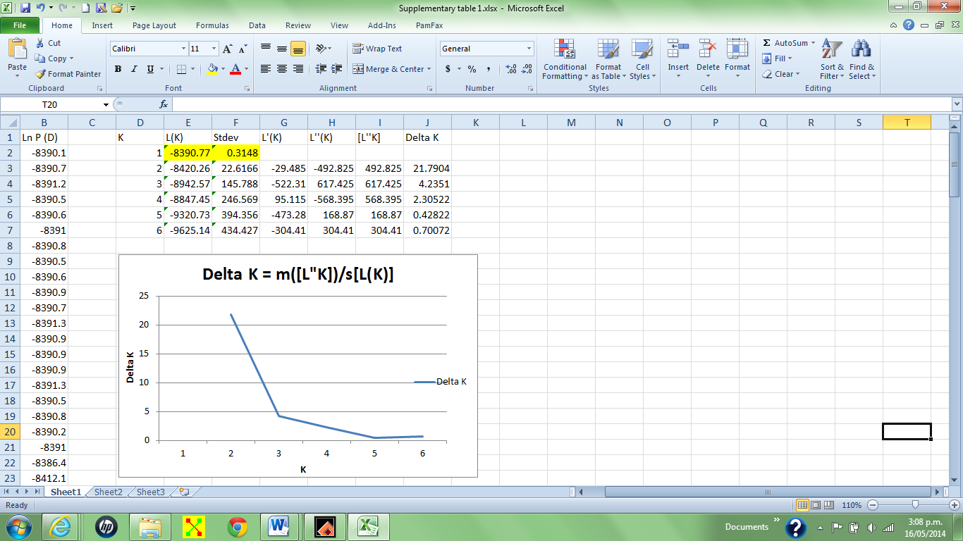

Estimates of Delta K to infer the true number of NZSL populations.

|  |  |  |  |  |
| --- | --- | --- | --- | --- |
| **Supplementary Table 5** | |  |  |  |
|  |  |  |  |  |
|  | **Dundas** | **Enderby** | **Figure of Eight** | **South East Point** |
| **Dundas** | 0 | 0.0056 | 0.0085 | 0.0096 |
| **Enderby** | 0.0056 | 0 | 0.0059 | 0.0095 |
| **Figure of Eight** | 0.0085 | 0.0059 | 0 | 0.0039 |
| **South East Point** | 0.0096 | 0.0095 | 0.0039 | 0 |

Pairwise FST (Weir and Cockerham, 1984) comparisons between the different breeding sites, based on microsatellite genotypes of live pups from 2003/2004 breeding season. Dundas Island n = 42, Enderby Island n = 77, Figure of Eight Island n = 24, South East Point n = 32.